Violet

| **First** | **Last** | **Middle** | **Comparison** |
| --- | --- | --- | --- |
| 0 | 10 | 5 | Violet > indigo |
| 6 | 10 | 8 | Violet > red |
| 9 | 10 | 9 | Violet = violet |
|  |  |  |  |
|  |  |  |  |

Green

| **First** | **Last** | **Middle** | **Comparison** |
| --- | --- | --- | --- |
| 0 | 10 | 5 | Green < indigo |
| 0 | 4 | 3 | Green > chanteuse |
| 3 | 4 | 3 | Green > dark brown |
| 4 | 4 | 4 | Green = green |
|  |  |  |  |

Yellow

| **First** | **Last** | **Middle** | **Comparison** |
| --- | --- | --- | --- |
| 0 | 10 | 5 | Yellow > indigo |
| 6 | 10 | 8 | Yellow > red |
| 9 | 10 | 9 | Yellow > violet |
| 10 | 10 | 10 | Yellow = yellow |
|  |  |  |  |

**Color array**:

| aqua | [0] |
| --- | --- |
| brown | [1] |
| chartreuse | [2] |
| dark brown | [3] |
| green | [4] |
| indigo | [5] |
| lavender | [6] |
| magenta | [7] |
| red | [8] |
| violet | [9] |
| yellow | [10] |

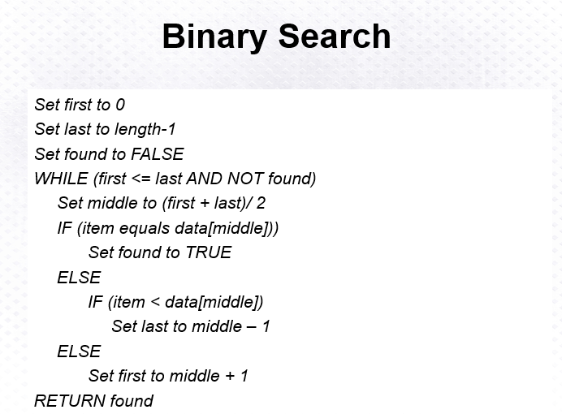

Above: Binary Search Algorithm

